# Azure HPC deployment for Autodesk VRED

Autodesk VRED is a 3D visualization application that helps automotive designers and engineers create product presentations, design reviews, and virtual prototypes by using interactive CPU and GPU ray tracing. VRED, which was previously limited to CPU, now uses GPU technology to support the high demands of consumers and provide interactive ray tracing and AI-powered denoising.

By using VRED, users can create digital prototypes to gain insight into how vehicles will look and perform. To be effective in guiding design decisions, digital prototypes need to look and behave as close as possible to real vehicles.

This article briefly describes the steps for running VRED on a virtual machine (VM) that's deployed on Azure. It also provides performance results. For more information about VRED, see the [Autodesk website](https://www.autodesk.com/products/vred/features/vred).

VRED 2022.1 was successfully deployed and tested on [NC64as_T4_v3](https://docs.microsoft.com/en-us/azure/virtual-machines/nct4-v3-series) & [NV48s_v3](https://docs.microsoft.com/en-us/azure/virtual-machines/nvv3-series) Azure VMs. Similarly VRED 2023.1 was deployed and tested on [NC64as_T4_v3](https://docs.microsoft.com/en-us/azure/virtual-machines/nct4-v3-series) and  [NVv5-series](https://docs.microsoft.com/en-us/azure/virtual-machines/nva10v5-series) Azure VMs

**Install VRED on a VM**

Before you install VRED, you need to deploy and connect to a VM and install the required NVIDIA drivers.

**Important**

NVIDIA Fabric Manager installation is required for VMs that use NVLink or NV Switch.

For information about deploying the VM and installing the drivers, see one of these articles:

* [Run a Windows VM on Azure](https://docs.microsoft.com/en-us/azure/architecture/reference-architectures/n-tier/windows-vm)
* [Run a Linux VM on Azure](https://docs.microsoft.com/en-us/azure/architecture/reference-architectures/n-tier/linux-vm)

To download VRED:

1. Sign into your Autodesk account.
2. Search for VRED in **Products and Services**.
3. Install VRED Professional.

**Install License Manager**

Before you install VRED on an Azure VM, you need to install Autodesk Network License Manager on the VM. You can [install Network License Manager for Windows here](https://knowledge.autodesk.com/search-result/caas/downloads/content/autodesk-network-license-manager-for-windows.html).

During installation, this folder is created: C:\Autodesk\Network License Manager.

After installation, generate a license file from your Autodesk account and save it in the Network License Manager folder. Create a text file named *debug.log* and save it in the same folder.

To generate the license file:

1. While signed into your Autodesk account, select **VRED Professional downloads**.
2. Select **Generate network license file**.
3. Provide the server or VM name and the physical or MAC address.
4. Select the product.
5. Select **Get License File**. The license file is generated.

To configure the license server on Windows:

1. Open Network License Manager by typing **lmtools** in the Windows search bar and selecting it in the results. A GUI opens.
2. Select **Config Services** and provide the service name, in this case, **Autodesk Network License Manager**.
3. Provide the path of the license file and the other requested paths.
4. Select **Start Server at Power Up** at the bottom of the window.
5. Select **Save Service** and follow the prompts that appear.
6. On the **Start/Stop/Reread** tab, select **Start Server**. You should see the service name **Autodesk Network License Manager** highlighted in blue.

The Network License Manager installation is complete.

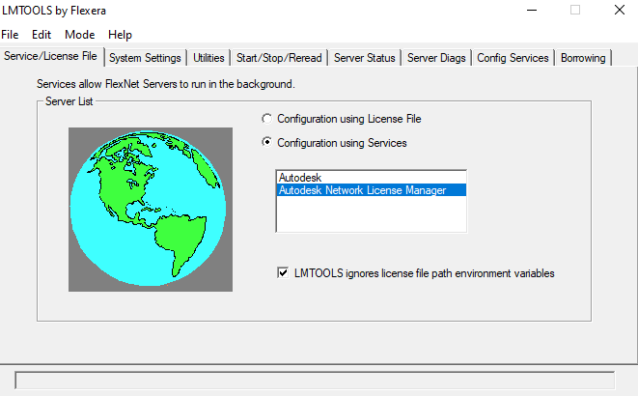

**Note**

For License configuration instructions, see [Configure and start your license server](https://www.autodesk.com/support/download-install/admins/network-licenses/configure-and-start-your-license-server).

**VRED performance on Azure VMs**

Rendering time is an important parameter for visualization and design software. Designers often spend a lot of time on the rendering process. By incorporating advanced capabilities like CPU and GPU ray tracing, VRED drastically reduces rendering times. To perform these complex rendering simulations on VRED, you need to use the right hardware. Microsoft partners with Nvidia to provide suitable infrastructure and hardware on Azure. Azure provides the fastest compute capabilities for both CPU-intensive and GPU-intensive workloads.

**Rendering**

The term *rendering* refers to the automatic process of generating digital images from three-dimensional models by using specialized software. The images simulate a 3D model's photorealistic environments, materials, lighting, and objects.

**Real-time rendering** is mainly used in gaming and interactive graphics, where images are calculated from 3D information at a fast pace. The dedicated graphics hardware has improved the performance of real-time rendering to ensure rapid image processing.

**Offline rendering** is used when less processing speed is required. Visual effects provide the highest standards of photorealism. In contrast to real-time rendering, there's no unpredictability with offline rendering.

**Ray tracing** is a rendering technique that can produce highly realistic lighting effects. Ray tracing generates lifelike shadows and reflections and much-improved translucence and scattering, taking into account light phenomena like reflection and refraction. In VRED, there are two primary ray tracing options: CPU ray tracing and GPU ray tracing.

**VRED application settings for rendering**

You can activate CPU and GPU ray tracing in VRED according to your requirements. To activate CPU/GPU ray tracing, select Visualization > Raytracing > CPU/GPU Raytracing.

**Anti-aliasing settings**

For CPU and GPU ray tracing rendering in these tests, we set the anti-aliasing option to high: **Visualization** > **Realtime Antialiasing** > **High**

**Rendering settings**

Select the rendering settings as shown here:

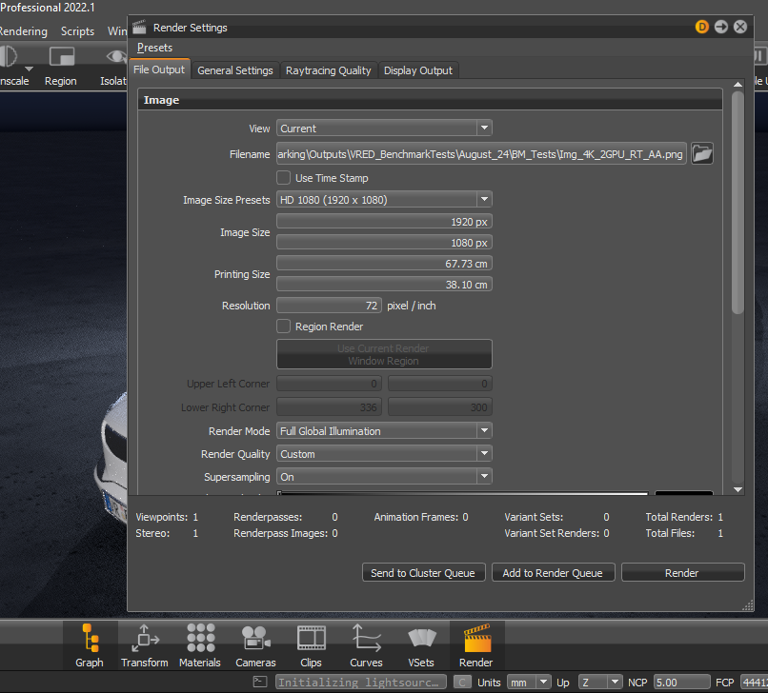

**Saving images**

You can save a rendered image to the desired location by selecting the path on the **File Output** tab in the **Render Settings** window. You can also choose an image size, like **HD** or **4K**, under **Image Size Presets**. We used **HD**.

**General Settings**

For CPU and GPU ray tracing, you need to select image samples for anti-aliasing. Your anti-aliasing output improves as you increase the number of samples. Under **General Settings**, we selected the maximum number: **1024** (1024 is just the maximum number of the slider but user can type higher value if needed)**.** For OpenGL, you can use a lower number, between 16 and 32 images, for example.

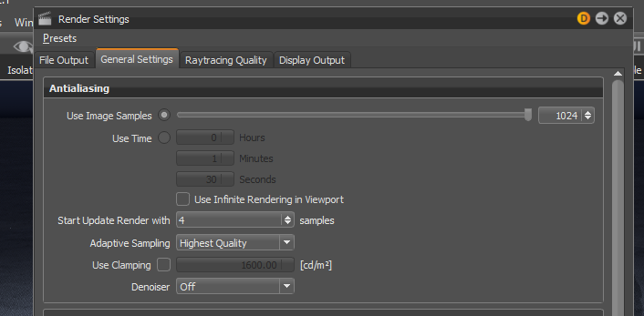

**Raytracing Quality**

In the **Raytracing Quality** settings, for the **Illumination Mode** for both interactive and still frame, we used **Full Global Illumination**.

**Benchmarking methodology for VRED performance analysis on VMs**

To analyse the performance of VRED we tested offline image rendering and calculated the rendering times for both CPU ray tracing and GPU ray tracing. For this analysis, we rendered 4k and HD images. We tested GPU ray tracing on NcasT4, NVv3 VM by using 1, 2, 3, and 4 GPUs and on NVv5 by using 1& 2 GPUs. For CPU ray tracing rendering, the application uses all CPU cores on the VM. We then calculated the relative speed increase of GPU rendering as compared to CPU rendering. The results are presented in the following sections.

## Model Details:

Following model is used for VRED Benchmarking on Azure

* Name: Automotive Genesis
* Image size used for Render process:

1. HD_1080 (1920x1080)
2. 4K (4096x2160)

* Resolution: 72 pixels/inch

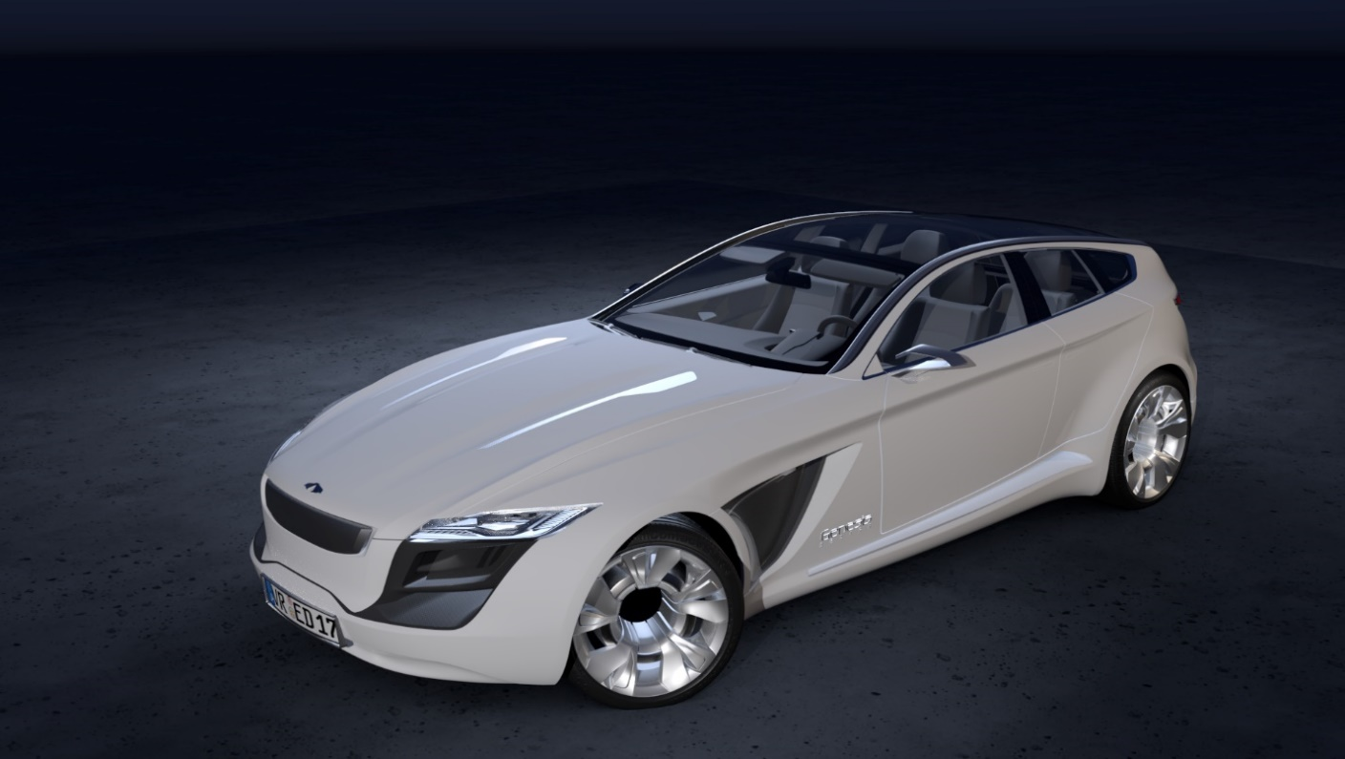

## Autodesk VRED v2022.1 Performance Results on NCas_T4 VM

**CPU and GPU Rendering times**

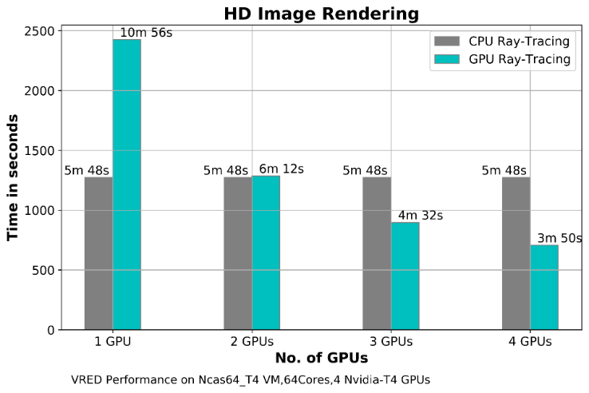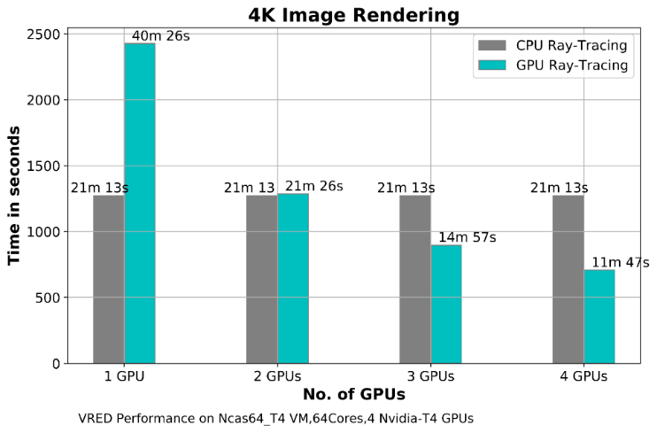

**Relative speedup between CPU and GPU raytracing:**

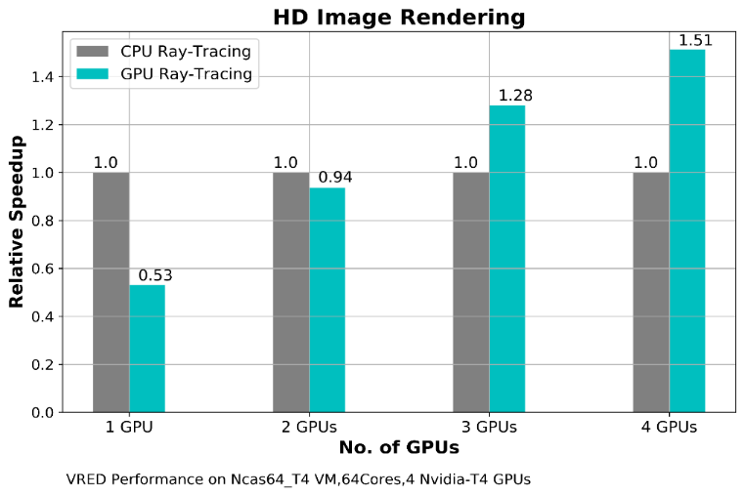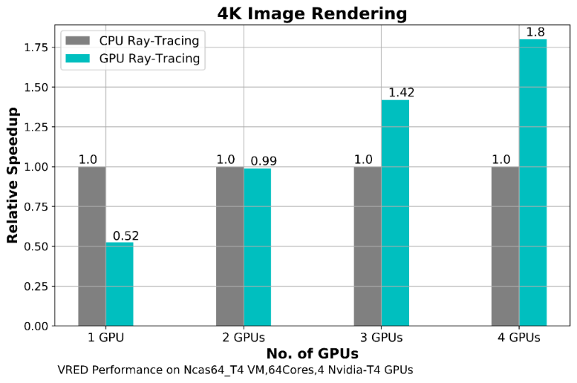

**Autodesk VRED v2022.1 Performance Results on NVv3 VM**

**CPU and GPU rendering times**

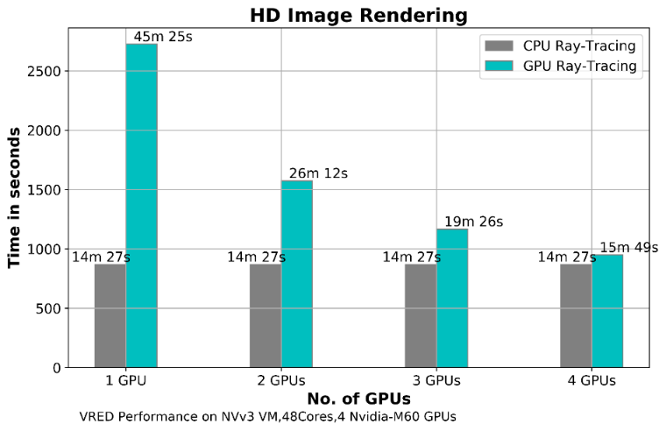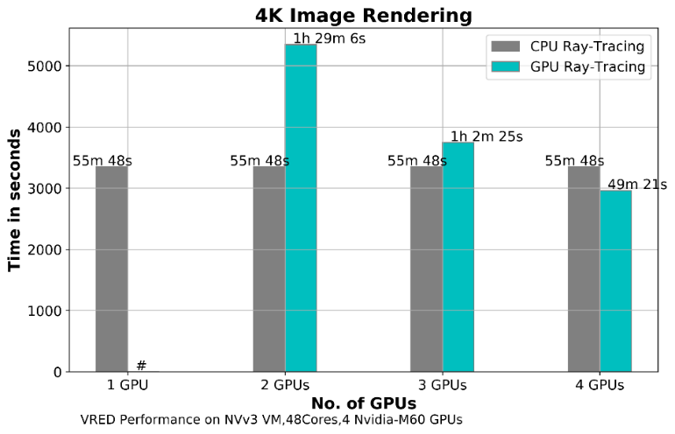

**Note**: GPU Rendering with 1 GPU settings on NVv3 VMs, application produced an error while rendering with 4K and higher resolution setting. It works fine with HD image rendering. It depends on the model complexity and environment setting for the model. For larger scale models, 1 GPU setting is not recommended.

**Relative speedup between CPU and GPU raytracing:**

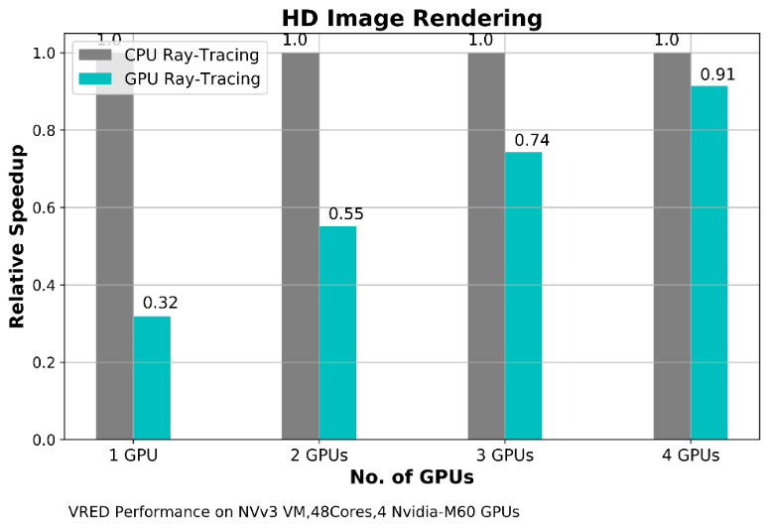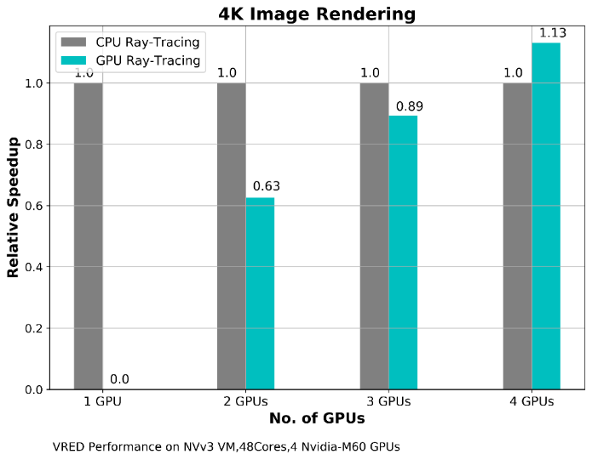

## Autodesk VRED v2023.1 Performance Results on NCas_T4 VM

**CPU and GPU rendering times**

|  |  |
| --- | --- |
|  |  |

**Relative speedup between CPU and GPU raytracing:**

|  |  |
| --- | --- |
|  |  |

## Autodesk VRED v2023.1 Performance Results on NVv5 VM

**CPU and GPU Rendering Times**

|  |  |
| --- | --- |
|  |  |

**Relative speedup between CPU and GPU raytracing:**

|  |  |
| --- | --- |
|  |  |

**Pricing**

Only model running time (rendering time) is considered for these cost calculations. Application installation time isn't considered. The calculations are indicative. The actual numbers depend on the size of the model.

You can use the [Azure pricing calculator](https://azure.microsoft.com/pricing/calculator) to estimate costs for your configuration.

You can use the rendering times provided in the following tables and the Azure hourly costs to compute rendering costs. For example, if the Azure VM hourly cost is $7.73 and the rendering time is 11 minutes and 20 seconds, the cost is $1.46. For current Azure hourly costs, see [Windows Virtual Machines Pricing](https://azure.microsoft.com/pricing/details/virtual-machines/windows/#pricing) or [Linux Virtual Machines Pricing](https://azure.microsoft.com/pricing/details/virtual-machines/linux/#pricing).

## Azure Cost for VRED v2022.1

**GPU rendering costs**

|  |  |  |  |
| --- | --- | --- | --- |
| VM | Number of GPUs on VM | 4K image render time | HD image render time |
| NC64as_T4_v3 | 4 | 11 min 47 sec | 3 min 48 sec |
| NVv3 | 4 | 49 min 21 sec | 15 min 49 sec |

**CPU rendering costs**

|  |  |  |  |
| --- | --- | --- | --- |
| VM | Number of CPU cores | 4K image render time | HD image render time |
| NC64as_T4_v3 | 64 | 21 min 13 sec | 5 min 48 sec |
| NVv3 | 48 | 55 min 48 sec | 14 min 27 sec |

## Azure Cost for VRED v2023.1

**GPU rendering costs**

|  |  |  |  |
| --- | --- | --- | --- |
| VM | Number of GPUs on VM | 4K image render time | HD image render time |
| NC64as_T4_v3 | 4 | 11 min 20 sec | 2 min 57 sec |
| NVv5 | 2 | 9 min 49 sec | 2 min 49 sec |

**CPU rendering costs**

|  |  |  |  |
| --- | --- | --- | --- |
| VM | Number of CPU cores | 4K image render time | HD image render time |
| NC64as_T4_v3 | 64 | 19 min 03 sec | 5 min 06 sec |
| NVv5 | 72 | 19 min 34 sec | 5 min 03 sec |

## Results and recommendations

* VRED was successfully deployed and tested on NCas_T4_v3, NVv3 and NVv5 series VMs on Azure.
* On NC64as_T4, GPU rendering is 1.73 times faster than CPU rendering.
* On NVv5, GPU rendering is 1.94 times faster than CPU rendering.
* For NVv3 VM, it was observed that there isn’t much improvement in GPU rendering times compared to CPU rendering time.

**Contributors**

*This article is maintained by Microsoft. It was originally written by the following contributors.*

Principal authors:

* [Hari Bagudu](https://www.linkedin.com/in/hari-bagudu-88732a19) | Senior Manager
* [Gauhar Junnarkar](https://www.linkedin.com/in/gauharjunnarkar) | Principal Program Manager
* [Vinod Pamulapati](https://www.linkedin.com/in/vinod-reddy-20481a104) | HPC Performance Engineer

Other contributors:

* [Mick Alberts](https://www.linkedin.com/in/mick-alberts-a24a1414) | Technical Writer
* [Jason Bouska](https://www.linkedin.com/in/jasonbouska) | Senior Software Development Engineer
* [Guy Bursell](https://www.linkedin.com/in/guybursell) | Director, Business Strategy
* [Sachin Rastogi](https://www.linkedin.com/in/sachin-rastogi-907a3b5) | Manager

*To see non-public LinkedIn profiles, sign into LinkedIn.*

**Next steps**

* [GPU optimized virtual machine sizes](https://docs.microsoft.com/en-us/azure/virtual-machines/sizes-gpu)
* [Windows virtual machines on Azure](https://docs.microsoft.com/en-us/azure/virtual-machines/windows/overview)
* [Linux virtual machines on Azure](https://docs.microsoft.com/en-us/azure/virtual-machines/linux/overview)
* [Learning path: Run high-performance computing (HPC) applications on Azure](https://docs.microsoft.com/en-us/learn/paths/run-high-performance-computing-applications-azure)
* [Virtual networks and virtual machines in Azure](https://docs.microsoft.com/en-us/azure/virtual-network/network-overview)
* [VRED Render Settings and Modes](https://knowledge.autodesk.com/support/vred-products/learn-explore/caas/CloudHelp/cloudhelp/2018/ENU/VRED/files/GUID-281BFE63-D833-431C-95E3-4EA418201954-htm.html)

**Related resources**

* [Run a Windows VM on Azure](https://docs.microsoft.com/en-us/azure/architecture/reference-architectures/n-tier/windows-vm)
* [Run a Linux VM on Azure](https://docs.microsoft.com/en-us/azure/architecture/reference-architectures/n-tier/linux-vm)
* [Deploy ADS CFD Code Leo for HPC on a virtual machine](https://docs.microsoft.com/en-us/azure/architecture/guide/hpc/hpc-ads-cfd)
* [HPC system and big-compute solutions](https://docs.microsoft.com/en-us/azure/architecture/solution-ideas/articles/big-compute-with-azure-batch)
* [HPC cluster deployed in the cloud](https://docs.microsoft.com/en-us/azure/architecture/solution-ideas/articles/hpc-cluster)